**INTERNATIONAL INSTITUTE OF INFORMATION TECHNOLOGY**

**HYDERABAD**

**SPRING 19**

**E2.103 ANALOGUE ELECTRONIC CIRCUITS**

ASSIGNMENT 3

The following questions are taken from University of Berkeley with grateful acknowledgement

Question 1 For the devices in the Fig. 2, |*Vt*| = 1V, *λ* = 0, *µnCox* = 50µA/V2, *L* = 1µm, and *W* = 10µm. Find *V2* and *I2*. How do these values change if *Q3* and *Q4* are changed to have *W* = 100µm.

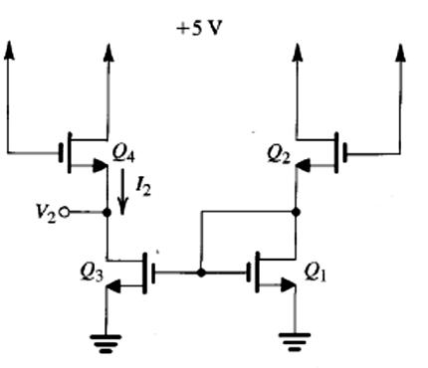

**Fig. 1**

Question 2 Calculate the DC operating points including the current flowing through each branch and DC voltage at each node for the circuits shown in Fig. 2

*VDD* = *VCC* = 5V, *βf* = 100, *VA* → ∞, *rb* = 0, *VBE(on)* = 0.7V, *VCE(sat)* = 0.2V,

*k’n* = 140μA/V2, *Vtn* = 0.7V, *k’p* = 40μA/V2, *Vtp* = -0.8V, *λ*=0,

*(W/L)1* = 10μm/0.5μm, *(W/L)2* = 5μm/0.5μm, *(W/L)3* = 10μm/0.5μm,

|  |  |  |  |  |  |
| --- | --- | --- | --- | --- | --- |
|  | ***VDD*** |  | ***VCC*** | ***RC*** |  |
|  | ***RL*** |  | ***RE1*** |  |
| ***M3*** | ***RB1*** | ***3kΩ*** |  |
| ***10kΩ*** | ***1.1kΩ*** |  |
|  |  | ***4kΩ*** |  | ***Q2*** |  |
|  |  |  | ***Q1*** |  |
| ***M2*** | ***M1*** | ***RB2*** |  |  |
|  | ***RE2*** |  |
|  |  | ***1kΩ*** |  |  |
|  |  |  | ***1kΩ*** |  |
|  |  |  |  |  |
|  | **(a)** |  | **(b)** |  |  |
|  | **Fig. 2** | |  |  |  |

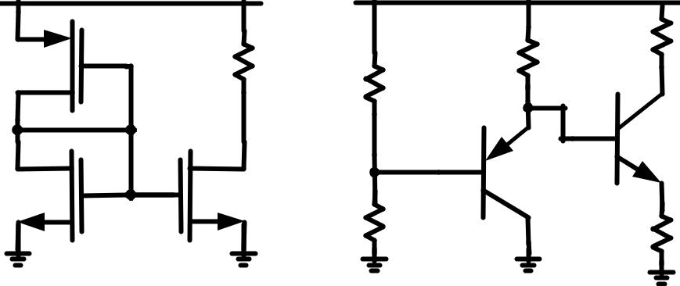

Question 3 Use inspection analysis to write expressions for the input resistance *Ri*, output resistance *Ro*, and gain *vout*/*vin* for each of the amplifiers in Fig 3. The expressions should be in terms of the given elements and parameters of the small-signal equivalent circuits for the transistors used. For each circuit, assume that all capacitors shown have infinite values.

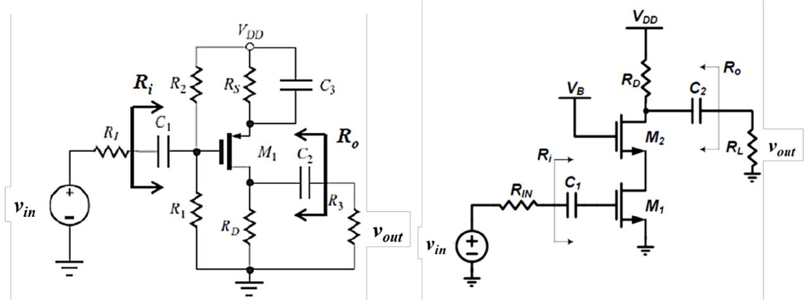

(a) (b)

**Fig. 3**

Question 4 Use inspection analysis to write expressions for the input resistance *Rin*, output resistance *Rout*, and gain *vout/vin* for each of the amplifiers in Fig. 4. The expressions should be in terms of the given elements and parameters of the small-signal equivalent circuits for the transistors used. For each circuit, assume that all the capacitors shown have infinite values.

|  |  |  |  |  |  |  |  |  |  |  |  |  |  |  |
| --- | --- | --- | --- | --- | --- | --- | --- | --- | --- | --- | --- | --- | --- | --- |
| **A)** |  | ***VCC*** | **B)** | ***VCC*** |  |  |  | **C)** |  |  | ***VCC*** |  |  |  |
|  |  | ***VCC*** |  |  | ***Rout*** | |  |  |  |  |  | ***Rout*** |  |  |
|  |  |  | ***RC*** |  |  |  |  |  | ***VCC*** | ***RC*** |  |  |  |
|  |  | ***RB1*** |  | ***CL*** |  |  |  |  | ***CL*** |  |  |
|  | ***CS*** |  |  |  | ***Vout*** |  |  |  |  | ***Vout*** |  |
| ***RS*** | ***Rout*** |  |  |  |  |  |  |  |  |  |  |
|  |  |  |  |  |  |  |  |  |  |  |  |  |
|  |  | ***Q1*** |  |  |  |  |  |  |  | ***RB1*** |  |  |  |  |
|  |  | ***CL*** |  |  |  | ***RL*** |  |  | ***CS*** |  | ***RL*** |  |  |
| ***Vin*** |  | ***Vout*** |  |  |  | ***RS*** |  |  |  |  |
| ***Rin*** | ***RB2*** | ***Q1*** |  |  |  |  |  | ***Q1*** |  |  |  |
|  |  |  |  |  |  |  |  |  |  |  |
|  |  |  |  |  |  |  |  |  |  |  |  |  |
|  |  | ***RL*** | ***CB*** | ***RB*** | ***CS*** | ***RS*** |  | ***Vin*** | ***Rin*** | ***RB2*** |  |  |  |  |
|  |  | ***IBias*** |  |  |  |  |  |  |  |
|  |  | ***-VCC*** |  | ***RE*** | ***Rin*** |  | ***Vin*** |  |  |  | ***Q2*** |  |  |  |
|  |  |  |  |  |  |  |  |  |  |  |  |  |  |
|  |  |  |  | ***-VCC*** |  |  |  |  |  |  | ***-VCC*** |  |  |  |

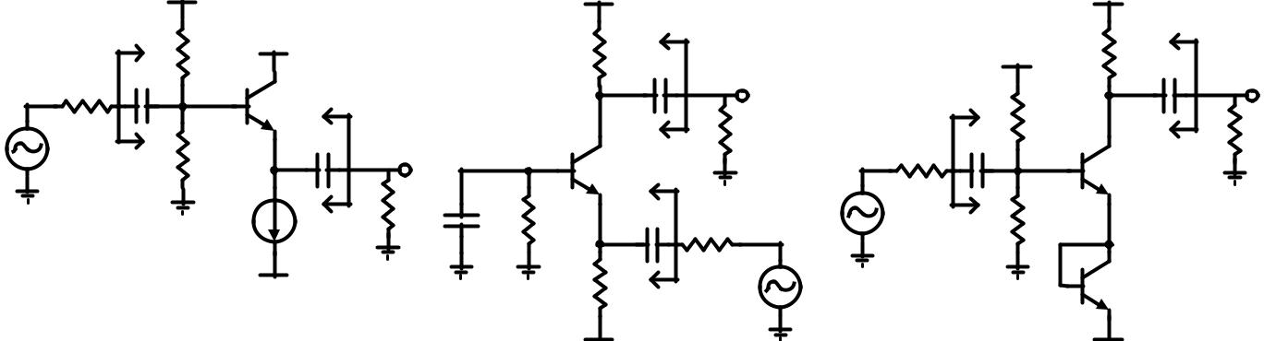

**Fig 4**

Question 5 For the Darlington emitter follower of Fig. 5, determine the dc collector currents in *Q1* and *Q2*, and then the small-signal input resistance and voltage gain. Neglect *rμ*, *rb* and *r*o, and assume that *VBE(on)* = 0.7V, *β* = 200, *VT* = 26mV (at 300k). Use inspection analysis wherever possible.

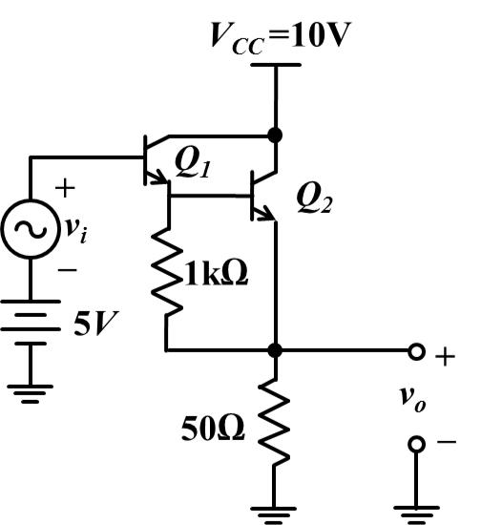

**Fig. 5**

Question 6 Calculate the output resistance, *Rout*, of the circuit in figure 6 as a function of *IBias*. Do not neglect *ro1* or *ro2* in this calculation, but you may neglect *rb* and *rμ*. If *IC2* = 1mA, what is *Rout* for *IBias* = 1mA and *IBias* = 0, assuming *VA* = 100V?

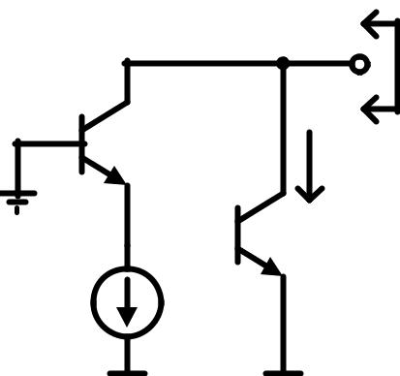

***Rout***

***Q1*** ***IC2***

***ac ground***  ***Q2***

***IBias***

**Fig6**